Topic- STAR COLLEGE

Karanpreet (300328786)

Douglas College

CSIS 1280- Multimedia Web Development

Prof.- Anupama Gupta

**Introduction**

In this project, you will see a whole information of an educational institute, called Star college. You will se different structure and different method to represent the content of webpage. It is trying to represent data with the use of CSS to increase the readability of the content and make it user friendly. With different CSS property like margin, border, padding, and many more, the website become more beautiful and attractive. Moreover, high level of graphics is used to make the page fascinating. The color of font and background is also chosen from color picker, to provide best visuals. Moreover, JavaScript is also used to give the dynamic look to webpage. You will see a lot of properties of JavaScript like event, styles, loops, conditions inside the webpage.

Site map of the website

* Four nav tags
* Students and Programs is divided into 2 and 3 pages, respectively.
* Science is also divided into 2 webpages.

STUDENTS

CONTACTS

HOME

PROGRAM

FUTURE

STUDENTS

CURRENT

STUDENTS

SCIENCE

BUSINESS

ARTS

SCIENCE

ASSOCIATE OF SCIENCE

ASSOCIATE OF COMPUTER SCIENCE

**FIRST PAGE**

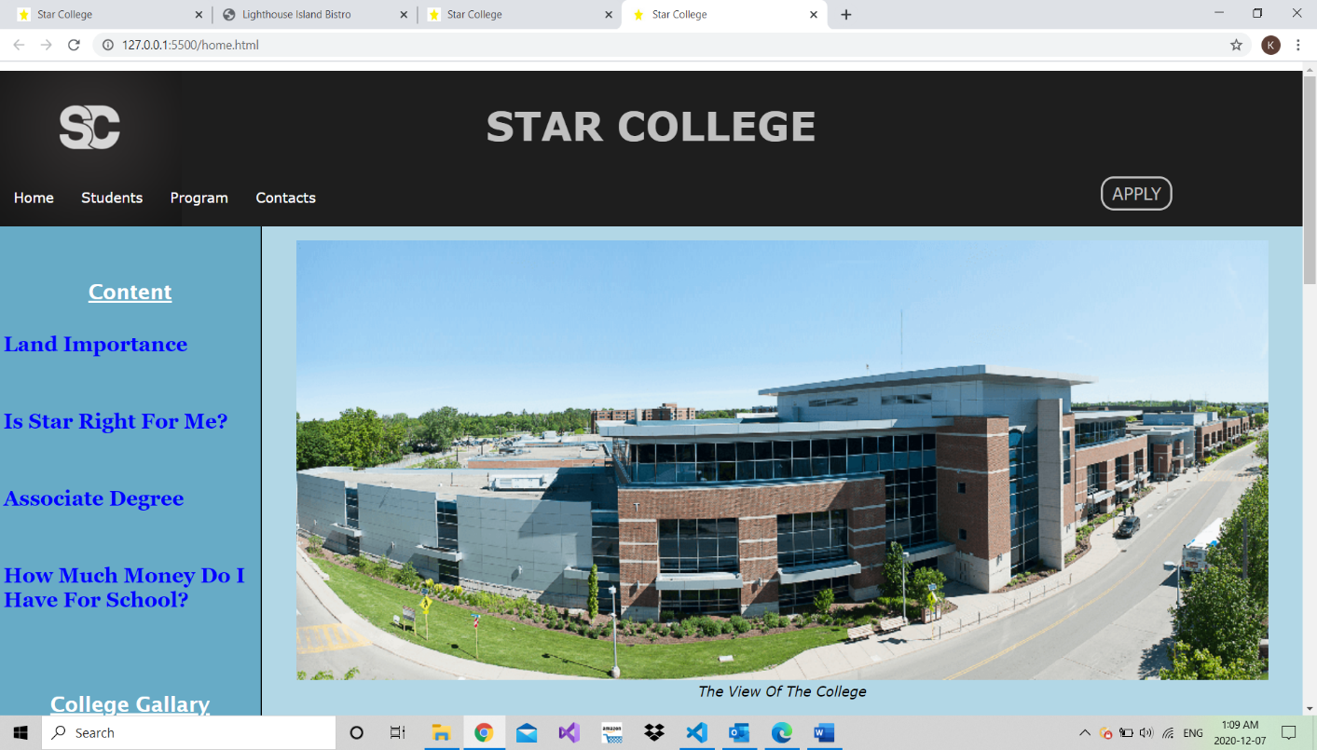

This is the first home page of the website. This page is divided into two sections as seen in the screen short. There is a logo, header, nav, main, and footer in this page. On the right-hand side, there is a apply word, it acts as a link or button. When you move your mouse on it you will see effects and same thing is done with nav tag. Also, when you click on the left side row i.e., contents you will see that you can directly reached to the content under that heading without scrolling. The image you can see in this picture changes after particular time.

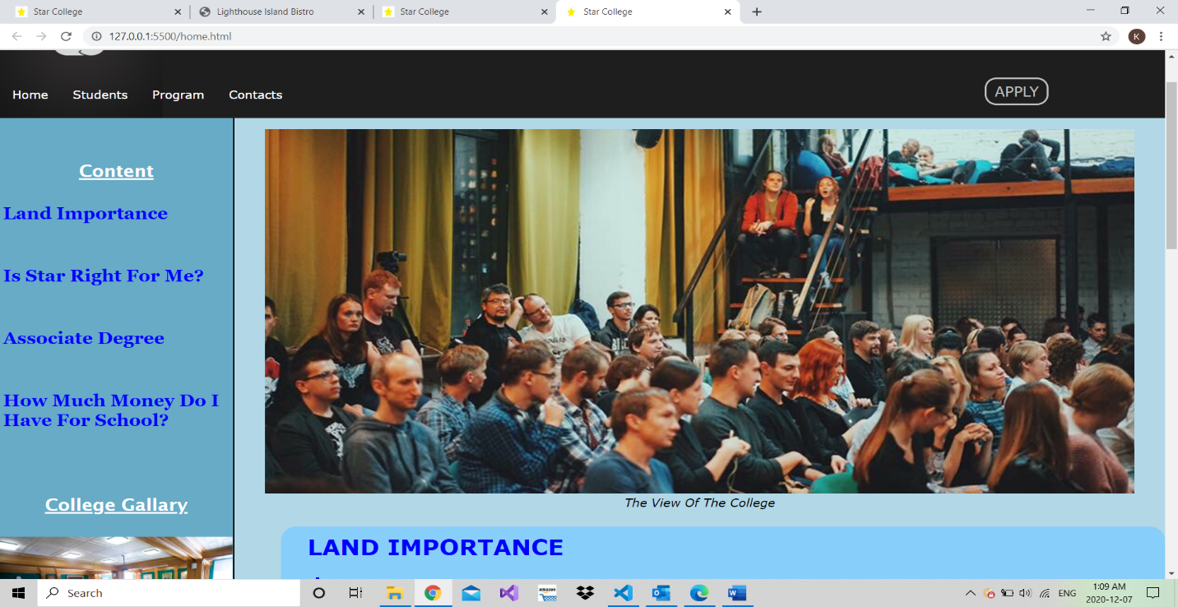

This picture just shows the image changes after some time (use of JavaScript).

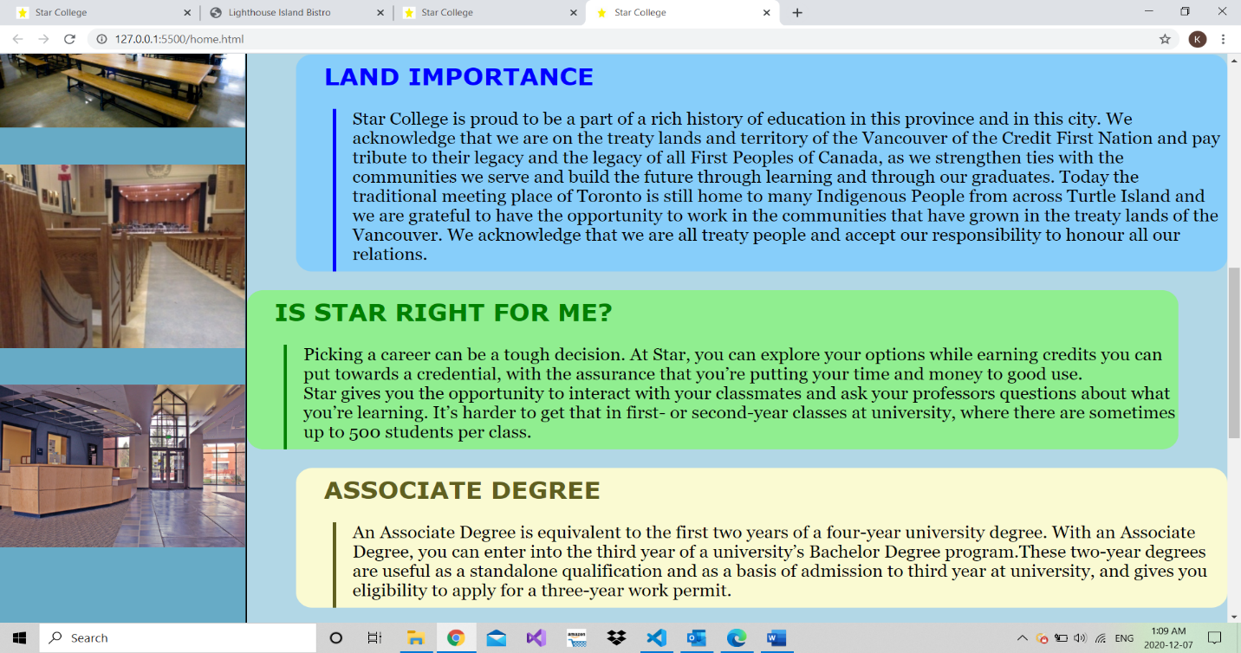

This image is showing the contents of the first page and which is design with CSS and also you can see some pictures on the left-hand side, it is the common places of colleges.

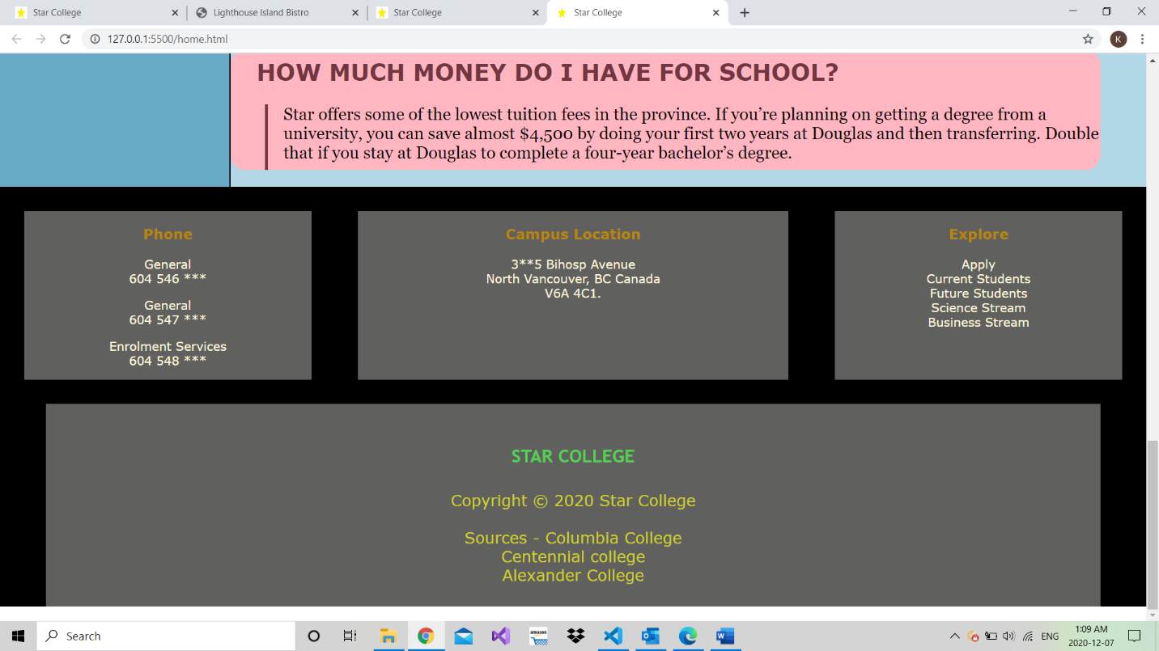

This figure is showing the footer of the table. It is designed with some CSS properties like color, background color. Display property is used to show separate structures, as you can see here.

HOME

LAND IMPORTANCE

IS STAR RIGHT FOR ME?

ASSOCIATE DEGREE

HOW MUCH MONEY DO I NEED FOR SCHOOL?

**SECOND PAGE**

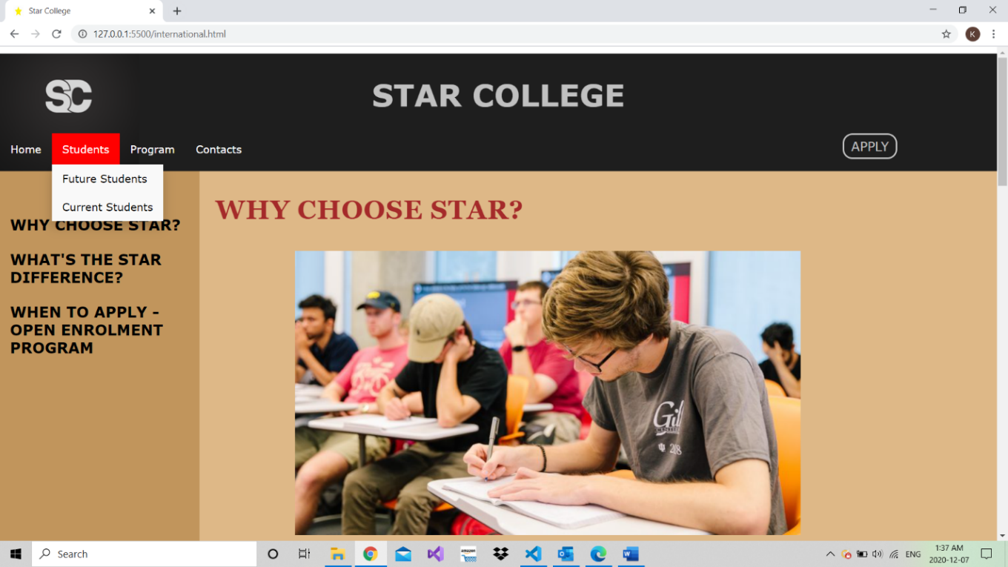

Now, when you move your mouse on the students on nav you will see a drop-down list which shows two items future students and current students. when you click on future students you will see this page. It is two structure pages as seen in screenshot and if you click on one of the links i.e., why choose star.... you will see that you are directly reached to that contents. Different and attractive images are there to increase the interest of reader.

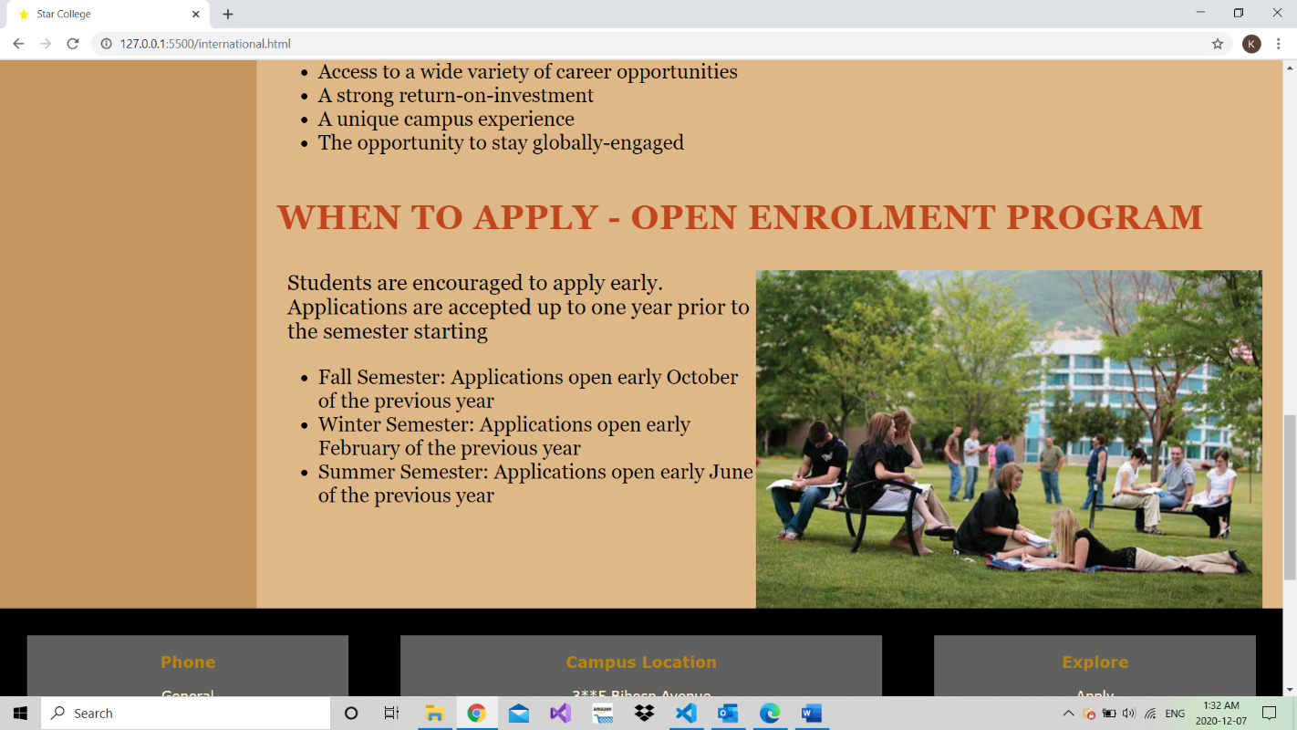

This image shows the other content of the page and you can see that ul list is used to show the data and other CSS properties are also used. The nav remain same as first page.

FUTURE STUDENTS

WHY STAR CHOOSE?

WHAT’S THE STAR DIFFERENCE?

WHEN TO APPLY OPEN ENROLMENT

PROGRAM?

**Third page**

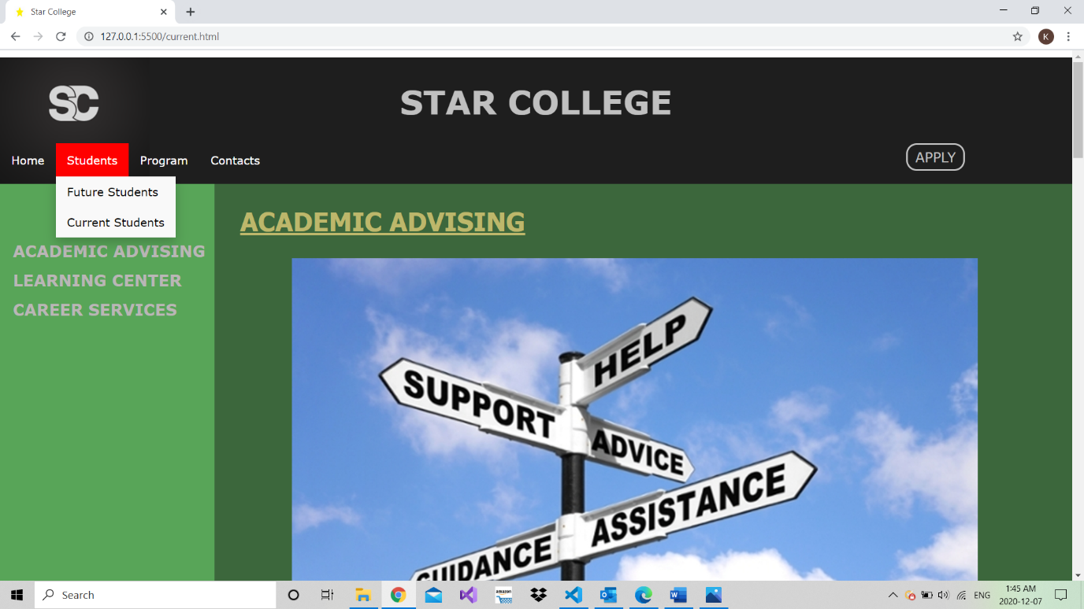

When you click on, the current students this page will appear to you. The structure of this page is also similar to the previous one but in this page, you can see a lot of CSS property. It is trying to show or display different CSS property in this page.

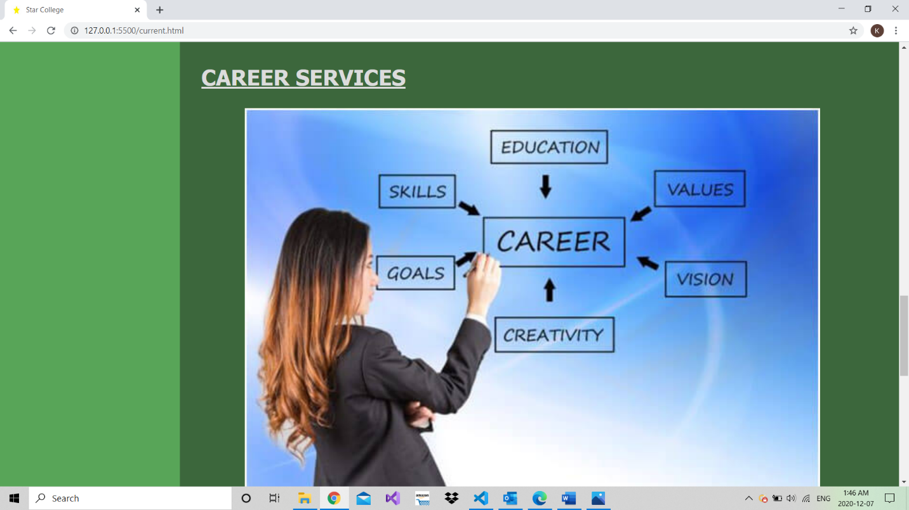

This is the image of middle of the page.

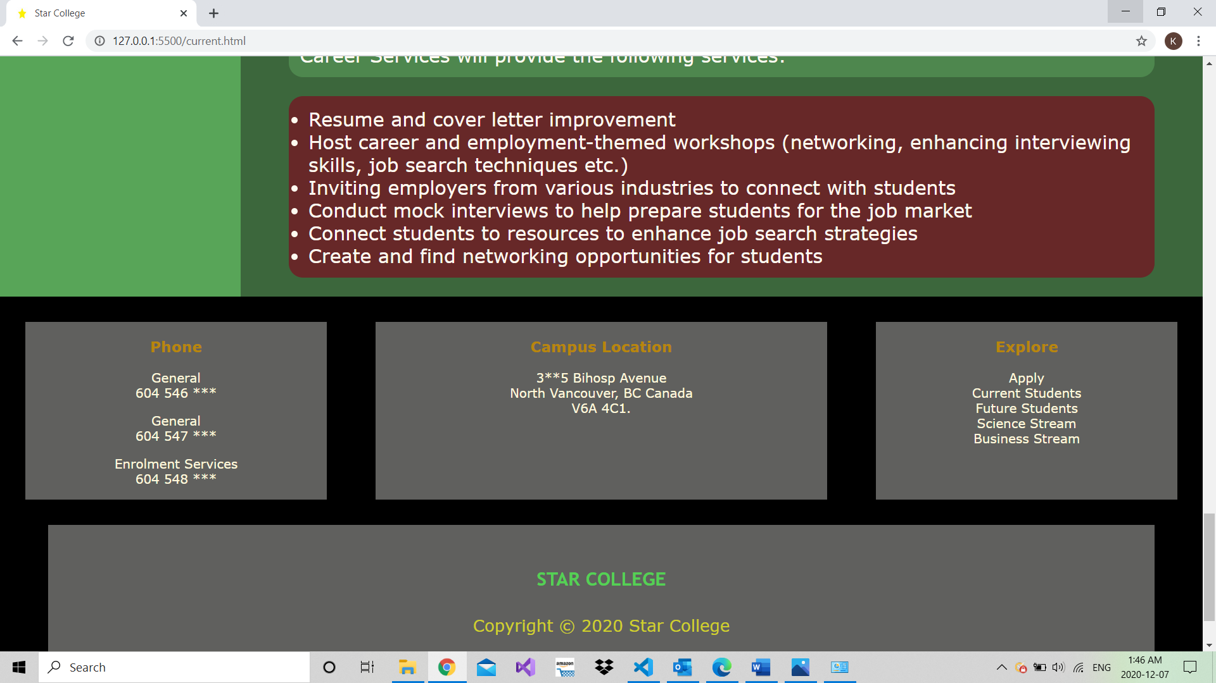

Here, in this figure you can see some more CSS properties, like border, border radius and box shadow.

**Fourth page**

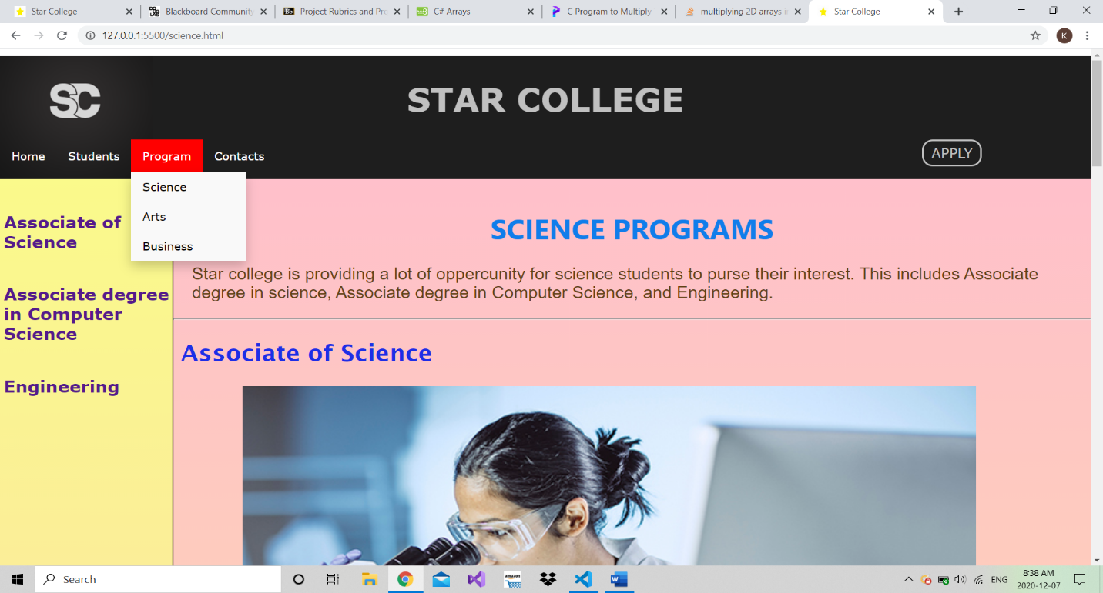

This is the fourth page of the website. As you can see when you move your muse on project on nav, a dropdown list appear. You will see three options when you select the first one you will see this page. This page contain content related to science stream. Some more CSS properties are used there. You will also see some JavaScript when you move your move on the left column of the page.

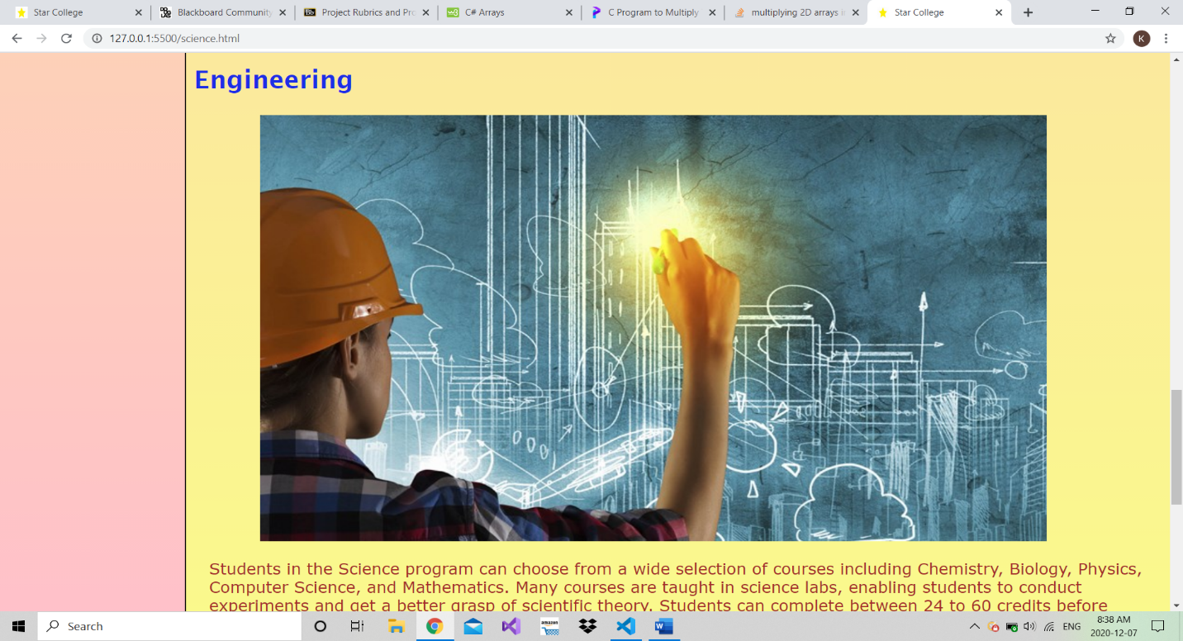

Attractive images are used to catch the focus of user. When a person goes through with the whole content of the paragraph, he or she will see a something like More… when he click on it, he is automatically transferred to that page.

**Fifth page**

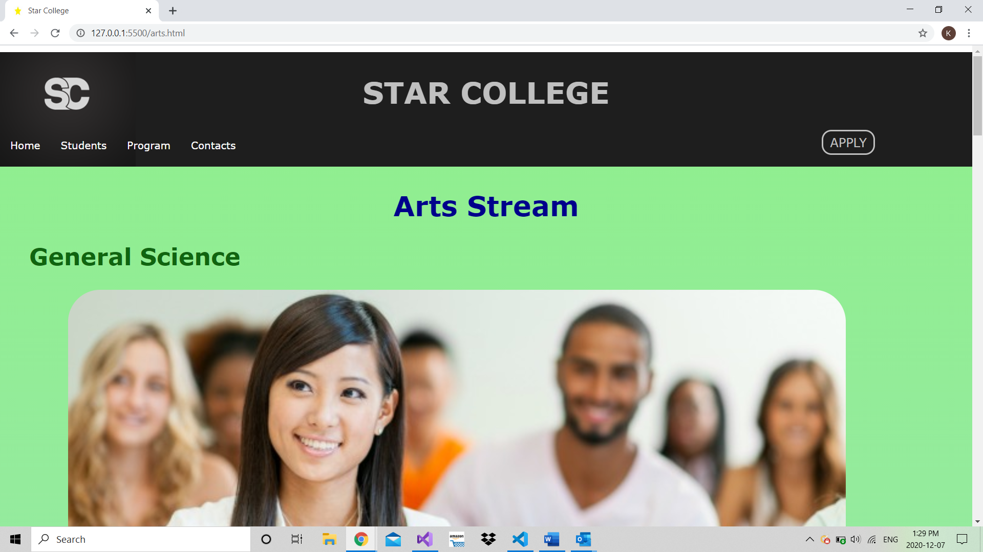

This is the fifth page of the website. You will see some more CSS properties here. Also, images are very attractive which also increase the interest of the reader. The font size and the font family are designed to increase the readability of the reader. This is the one column page which is different from others. When you move down to the page the color change automatically with liner-gradient CSS property.

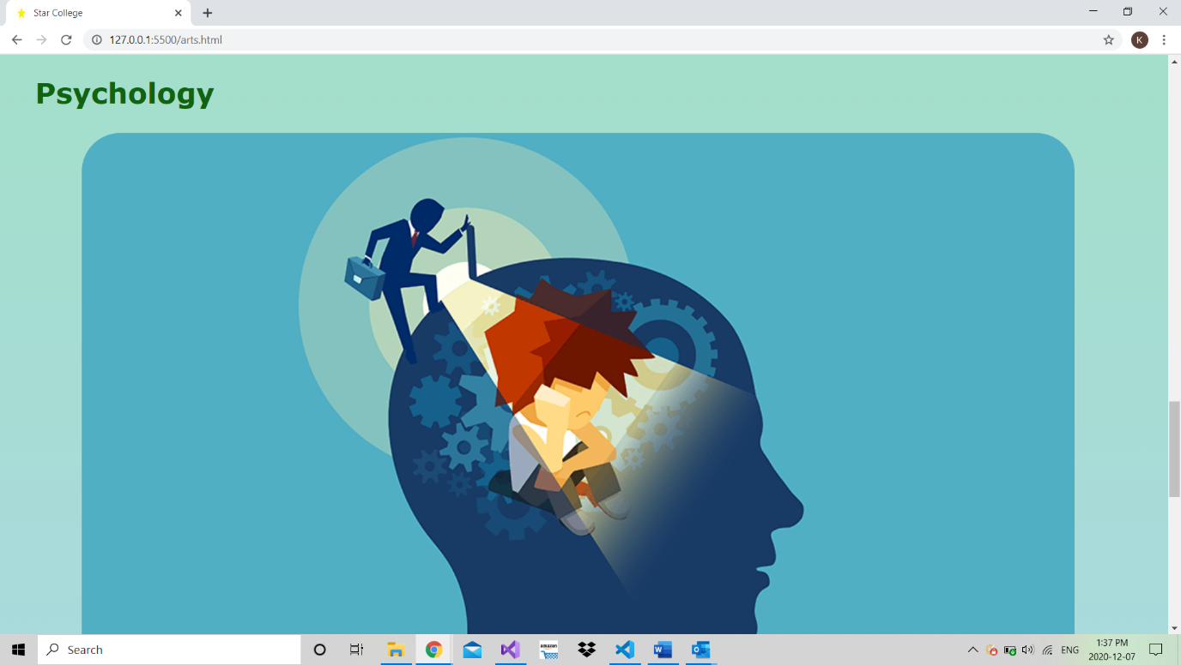

This is the other part of that page. You can see that this images are designed beautifully, and the color changes to blue.

**Sixth page**

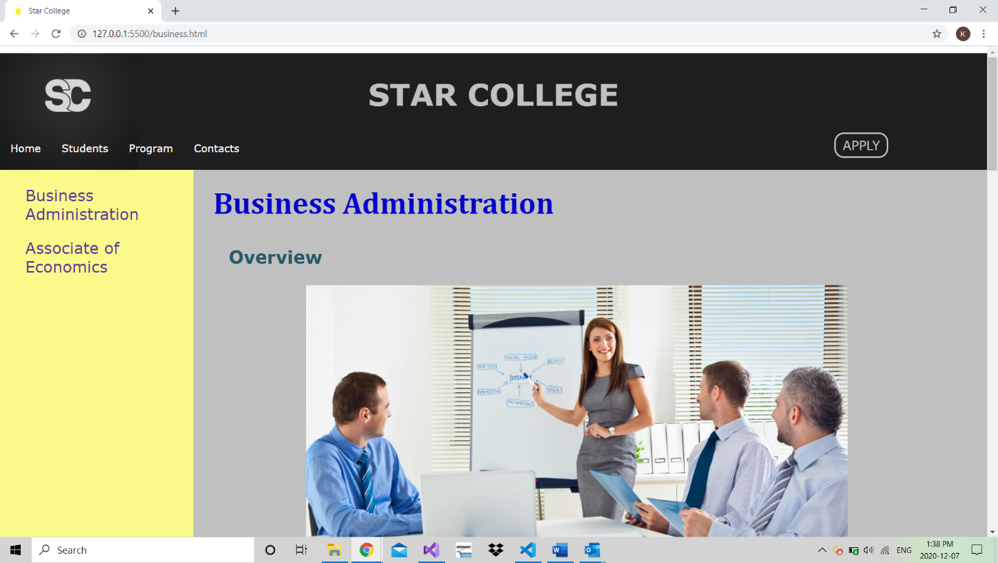

This is the sixth page of the website. You will find it in program in nav. This page is double column. Again, you will be reached to the content just by clicking heading on the left column. In this page, it is trying to use margin and padding properties.

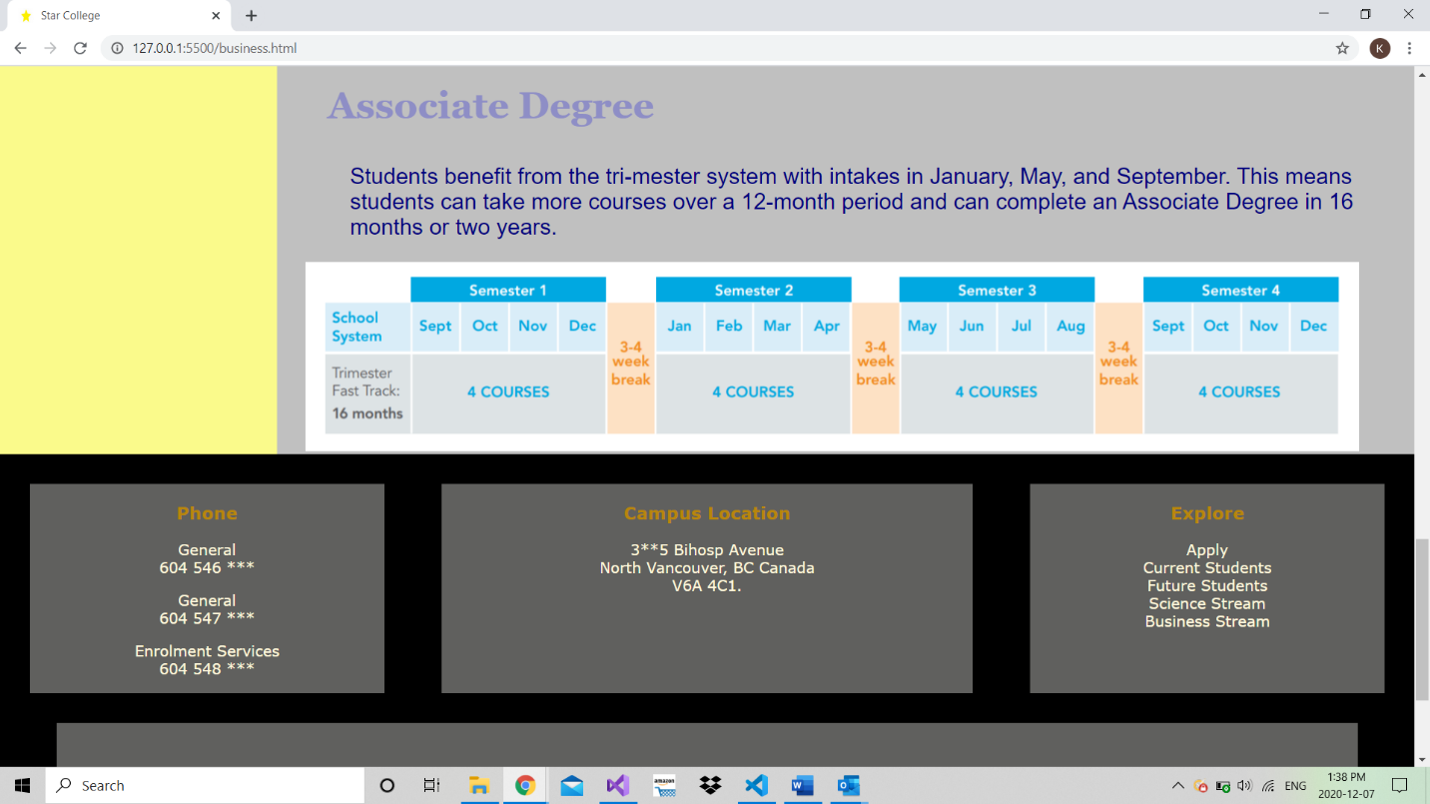

This is the end of that page.

**Seventh page**

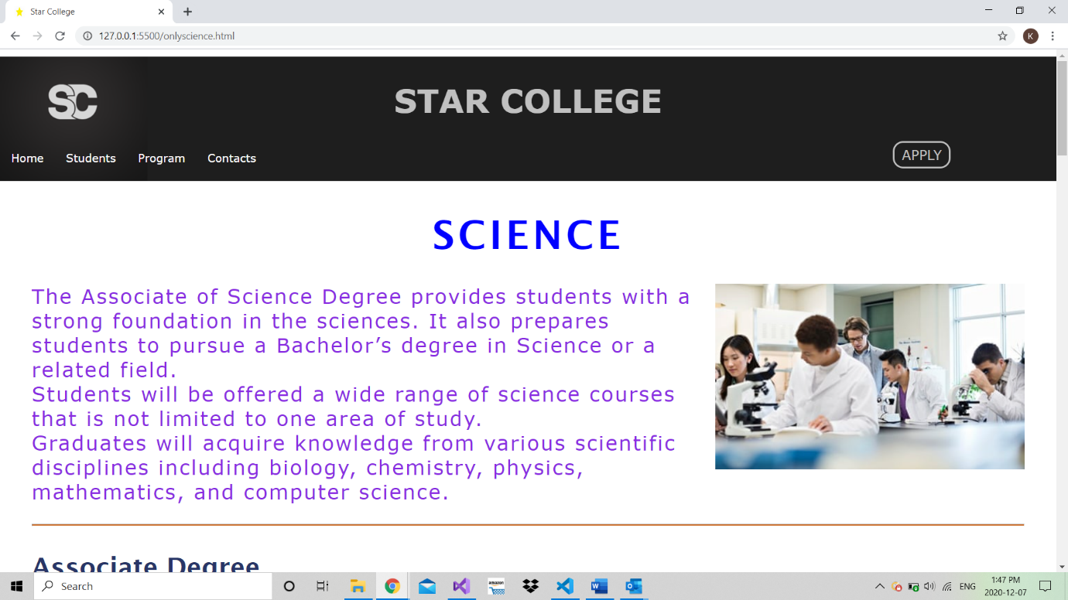

When you were on science page in associate of science, you saw a word more (More…) link. When you click on it, this page will appear to you. So, this is the seventh age of the website. This contains more information. Suppose if reader is interested science, he can read it here. CSS properties like letter spacing or word spacing is used here in addition to other properties.

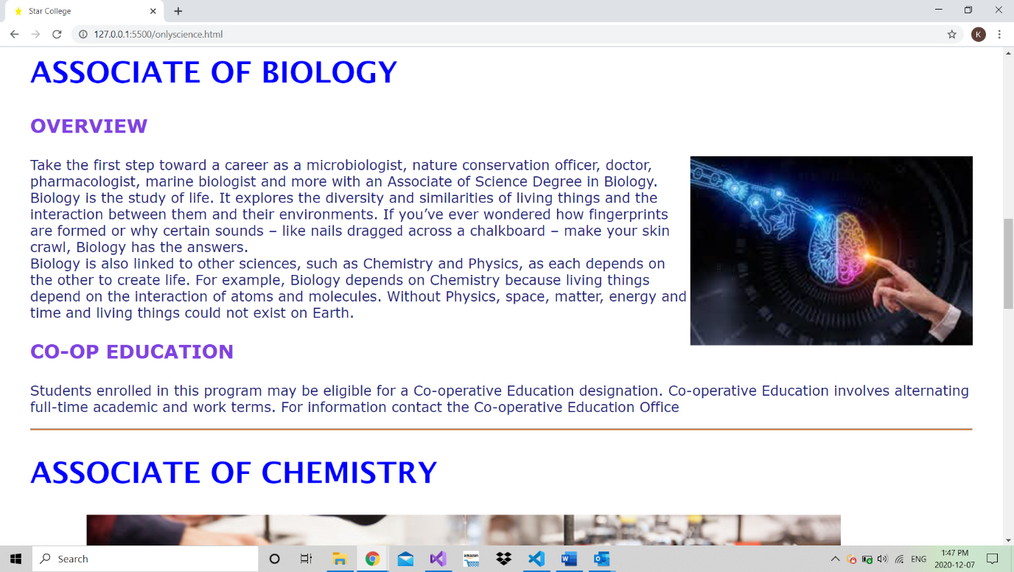

This is the middle of the page you will see a lot of information. Some images are floated to right and some on left to create the interest of user and make the website user friendly.

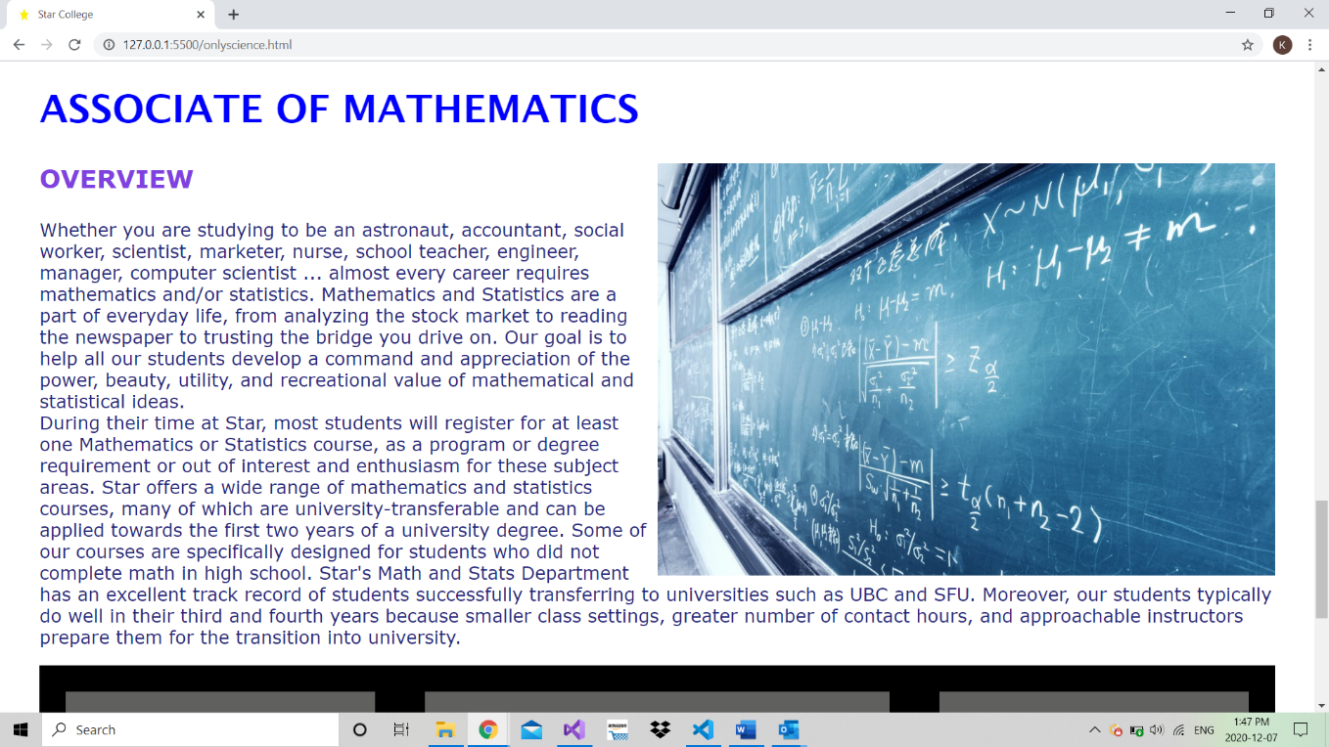

This is the final content of the page after this you will see footer which same as other pages.

**Eighth page**

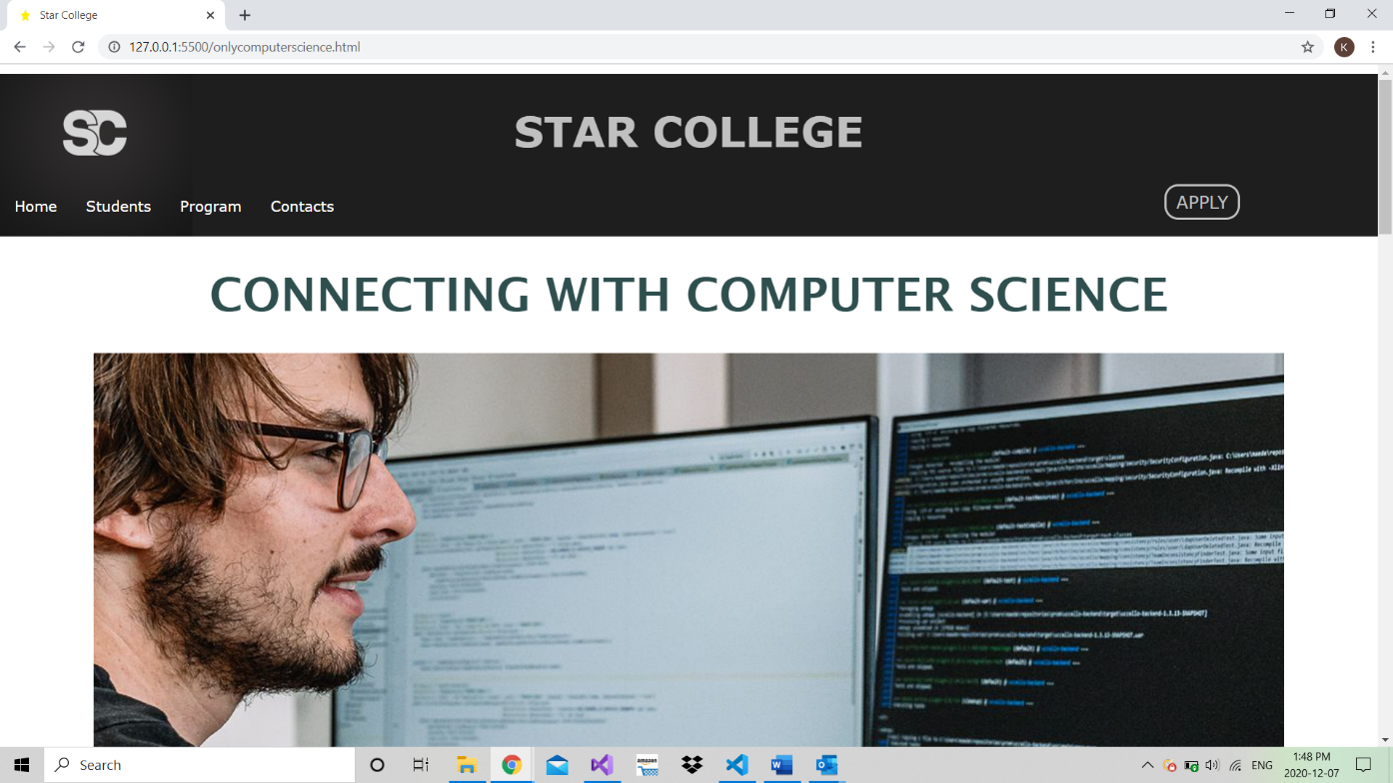

This is the eighth page of the website. When you were on science page in associate of computer science, you saw a word more (More…) link. When you click on it, this page will appear to you. So, this is the seventh age of the website. Suppose if reader is interested science, he can read it here. CSS properties like letter spacing or word spacing is used here in addition to other properties. It is try to separate the content from the original page.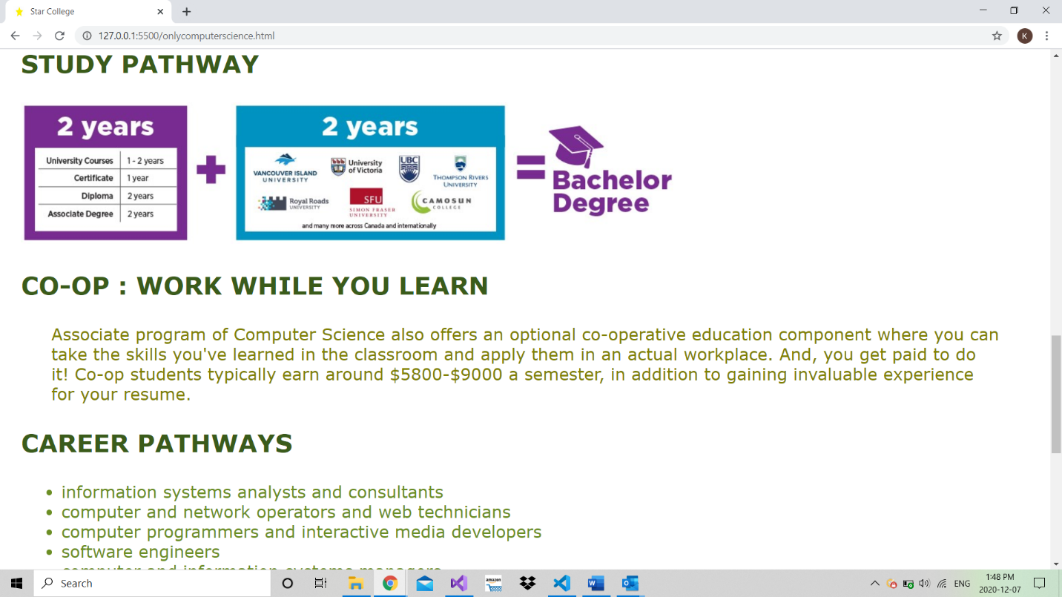

This is the middle view of that page.

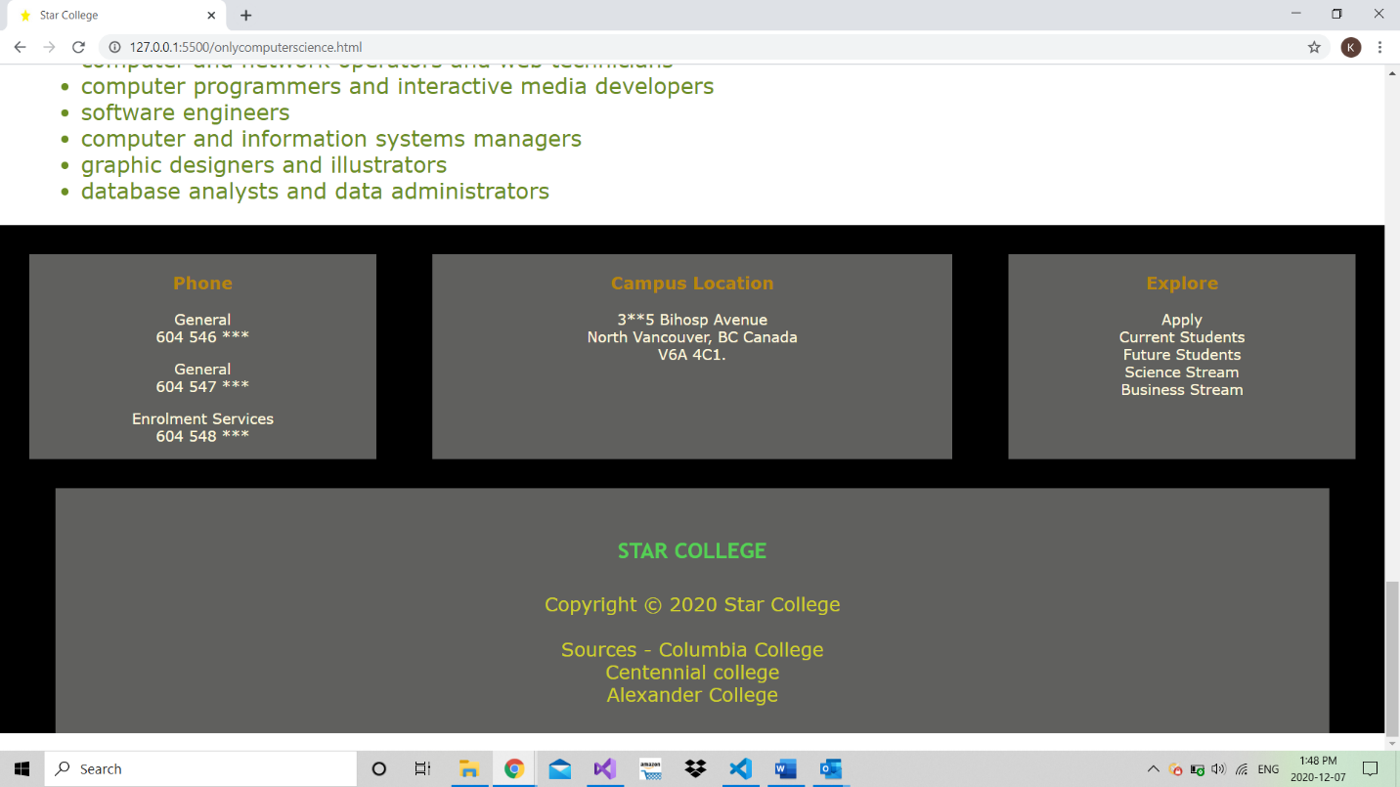

This is the last screenshot page. it shows the footer of the table.

**Ninth page**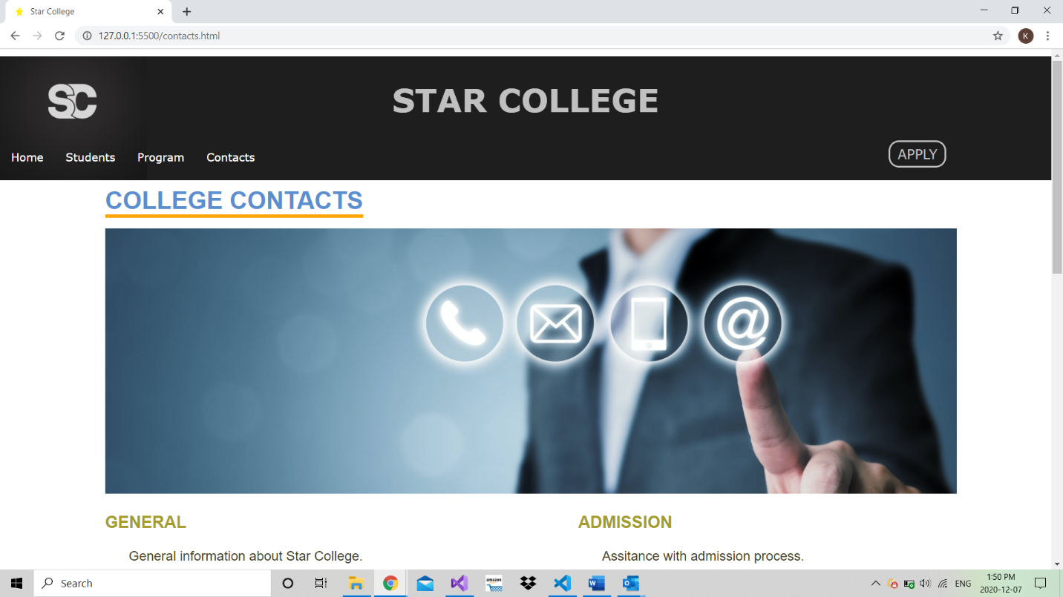

When you go on the contacts on the nav and click on it. You will see this page. Display flex property is used to make the structure of the page.

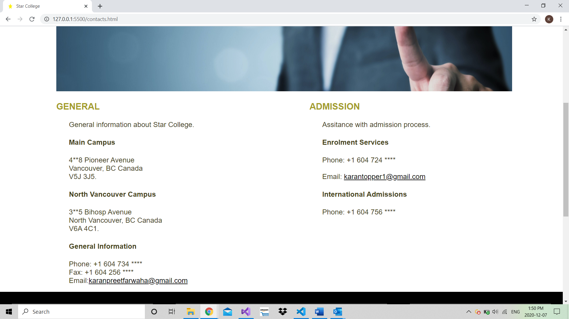

**Tenth page**

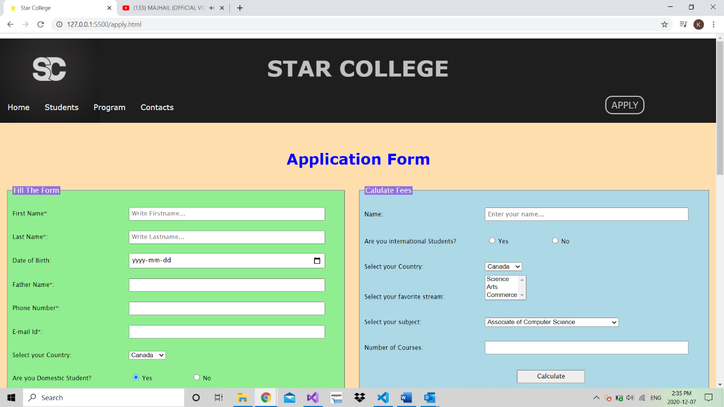

This is the last page of the website and it contain most of the JavaScript i.e., loops, if-else, events, styles and many more. Reader will be very attracted with the graphics. Well, display flex property is used here , and CSS & JavaScript is used to change and effects of the page.

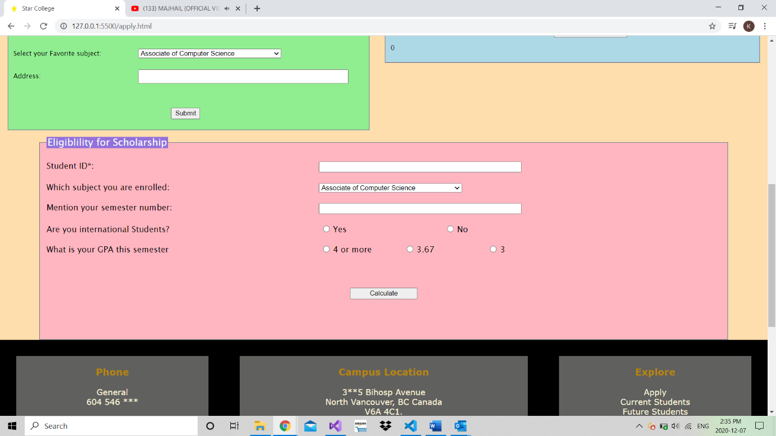

This is the last screenshot of the page.

**REFERENCES**

1. Centennial college - <https://www.centennialcollege.ca/>
2. Alexander college- https://alexandercollege.ca/
3. Douglas college- https://alexandercollege.ca/
4. Columbia college- https://www.centennialcollege.ca/